


The 4-H Newsletter








Party with the Pumpkins
Tuesday, October 28th
Grab your costumes and join us for Party with the Pumpkins on October 28th from 4:30pm to 6:30pm at Lutcher Park. This is a FREE trick or treating event that is open to ALL AGES. Participants do not have to be registered 4-H members in order to attend. We will have local businesses and companies from neighboring parishes handing out candy, trinkets and more. This year, we will debut The Monster Mile Bike Ride starting at 4pm at the Lutcher Senior Center! We can't wait to see everyone in their costumes and decorated bikes!
Safety & Health Day
Sunday, November 16th
Come out to Lutcher Park on Sunday, November 16th from 12:00PM-3:00PM where we will have multiple booths, obstacles courses, and activities set up for youth and adults to participate in! So far, we will have booths covering ATV safety, fire safety, road safety, water safety, train safety, mental health, and nutrition. ALL of St. James Parish is invited! All ages welcome, youth and adults! Attendees can enter for a chance to win a bicycle and helmet (2 chances). Make sure to visit the 4-H booth to enter! There will also be a TRAIN for youth and adults to ride provided by CN Railroad! All attendees will also be going home with give aways and goodie bags. St. James 4-H Junior Leaders will be selling gumbo to help the cost of trips and events later in the year.
How To Enroll in 4-H:
To enroll in the St. James Parish 4-H program, you can either enroll directly on 4-H Online (www.v2.4honline.com) or complete the paper enrollment form and submit it to your child's school club leader or turn it in to the 4-H office. All 4th-12th graders can join the 4-H program by paying the required $5.00 fee to be enrolled. If you have any questions about enrollment, please contact the 4-H office at 225-562-2320 or the 4-H Agents - Carly Dufresne (cmboudreaux@agcenter.lsu.edu) or Laynie Smith (larceneaux@agcenter.lsu.edu).
Calendar of Events

October
5-11: National 4-H Week
8: Mandatory Livestock Meeting, 6pm & Pet Show Entry Deadline
13-14: Cooking Club Kick-Off Camp
15: Jr. Leader Mtg. – 6pm
22: Ag Day, Fast Food Farm
24: Paws for a Story Contest Due & Shooting Sports Registration Due
28: Party with the Pumpkins
29: Sewing Club
30: Paint-A-Pumpkin Judging
31: Parish Broiler Order Due

November
1: Turkey Shoot
5: Pecan Orders Due
5: Cooking Workshop
11-12: Challenge Camp
13: Jr. Leader Mtg. – 6pm
14: Bumper Stickers & Bookmark Entries Due
15: Bash on the Bayou
16: Safety & Health Day
16: Pet Show
18: Fall Cookery
20: Sewing Club
21: Beef Posters Due
24: Fall Cookery Drop Off

St. James Parish October 2025

Jr. Leader Club
What is the Jr. Leader Club?
The Jr. Leader Club provides members with the opportunity to learn about the qualities needed to be a leader while participating in fun activities and events from the parish to the state level. This club focuses on developing leadership skills and giving back to the community. As a Junior Leader you can make an impact, while having fun and making life-long memories. Members are expected to assist with parish events year-round, fundraise and actively participate in the club. Meetings are held once a month at the 4-H office.

Who can join?
Jr. Leaders must be a 7th-12th 4-H member enrolled in 4-H Online. All 7th-12th grade At-Large members can join the Jr. Leader Club as well. Our next Jr. Leader Meeting will be on
October 15th at 6pm at the 4-H office.

Jr. Leader Pecan Fundraiser
The St. James 4-H Jr. Leader Club will once again, host our Pecan Sale Fundraiser this Fall! Pecan Fundraising products are made by the Pointe Coupee Pecan Company.

All pecans come in 16oz. bags with several options including plain halves, praline

crunch, chocolate covered, dark chocolate covered, roasted, sugared & chocolate covered almonds.

The deadline to submit your order form is November 5, 2025.
Please call the 4-H office to order or place an order with a Jr. Leader member.



National 4-H Week:
October 5-11, 2025
National 4-H Week will be celebrated October 5-11, 2025. We challenge each of our school clubs to show your 4-H spirit by decorating your school halls and yard in the 4-H colors: green and white. Each school can choose a theme by incorporating the 4-H colors or simply just decorate to show their spirit!
School Spirit Judging – Friday, Oct. 10th
Decorate your school halls & yard by incorporating the National 4-H Colors: Green and White! Ms. Carly and Mrs. Laynie will come by the schools to judge decorations.
4-H Blessing Box Hygiene Drive
The Months of September and October
4-H is collecting hygiene items for our four Blessing Boxes across the parish. 4-H members and school clubs may collect items like shampoo, soap, toothbrushes, toothpaste, deodorant, etc. to be turned into the 4-H office. The school club that donates the most items will receive a treat at their November club meeting.



Livestock Program
Interested in joining the 4-H livestock program? 4-H members ages 9-18 are eligible to show livestock. The Livestock program is one of our largest programs teaching youth lifelong skills including teamwork, responsibility, belonging and much more!
St. James Parish Poultry & Rabbit Show: January 16, 2026
St. James Parish Livestock Show: January 23-24, 2026
Southeast District Livestock Show: January 28-31, 2026
LSU AgCenter State Livestock Show: February 14-21, 2026
Mandatory Livestock Meeting
Wednesday, October 8, 2025 – 6:00pm – PR Building (LHS)
Deadline dates, show rules, 4-H Online, Fair Entry and more will be discussed at the annual mandatory livestock meeting. If you are a new livestock member or a returning member, please make every effort to attend. Parents/Guardians should be in attendance with their livestock exhibitor at the meeting.
Please email Carly (cmboudreaux@agcenter.lsu.edu) if you have any questions.

Market/Commercial Deadlines:
November 10, 2025
Beef & Dairy Commercial Heifers, Market Lambs & Commercial Ewes, Market goats & Commercial Does: Must be validated by exhibitor and submitted to the St. James Parish Extension Office by 4:30 p.m. Must also be uploaded in 4-H Online.
December 1, 2025
Market & Commercial Hogs: Must be validated by exhibitor and submitted to the St. James Parish Extension Office by 4:30 p.m. Must also be uploaded in 4-H Online.
Breeding Possession Deadlines:
Breeding animals must be in EXHIBITORS’S name and uploaded in 4-H Online by 4:30pm on the dates below.

November 10, 2025
Beef, Sheep, Goats & Dairy Breeding
November 17, 2025
Miniature Cattle
December 1, 2025
Swine Breeding
Shooting Sports Program
The St. James Parish 4-H Shooting Sports Club is very excited to begin this year’s activities! All participants must be a member of St. James Parish 4-H school club or a 4-H member-at-large. So, enrolling in 4-H Online is your first step.

Disciplines offered: Archery, BB Gun, Air Pistol, Air Rifle, Smallbore Rifle, Smallbore Pistol and Shotgun.
Registration Fee: $30
Shooting Sports Registration Due: Friday, October 24, 2025
Payment and Registration form must be turned into the 4-H office (2204 S. Albert Street Lutcher, LA 70071) by this deadline. Forms can be picked up from the 4-H office or a Shooting Sports Coach.
Please call the 4-H Office at 225-562-2320 or email your information to Mrs. Laynie at larceneaux@agcenter.lsu.edu to sign up for Shooting Sports.
National Character Counts Week: October 19-25, 2025

Bumper Sticker & Bookmark Contest
- Bumper Stickers must be 11 inches long and 3 inches wide
- Bookmarks must be 8 inches long and 2 inches wide
- Draw your bumper sticker or bookmark (entries must be in color)
- Choose One Pillar of Character
- Add your message or slogan.
- Be neat and spell words correctly. No glue or tape can be used.
- Include your name, grade, and school on the back.
Mrs. Carly and Mrs. Laynie will collect your entries from your club leader, or you may turn them in to the 4-H office by Friday, November 14th.
Paint-A-Pumpkin Contest
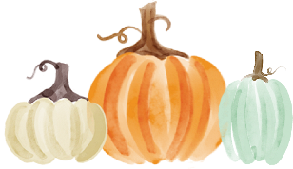
It’s time to go to the pumpkin patch! Our annual Paint-A-Pumpkin Contest Judging will take place on Thursday, October 30, 2025. Pumpkins will be brought to school on this day to be judged. Club leaders will inform you on where to drop off your pumpkins.
Contest Rules:
- Real pumpkins only.
- Painted pumpkins only. No carved pumpkins.
- Stickers, paper, pipe cleaners, etc. may be added. NO glitter!
- You may only enter ONLY 1 pumpkin in 1 of the categories below for judging.
- You may NOT submit more than one pumpkin in the contest.
- Each entry will receive a Blue, Red or White ribbon.
- 4-Hers will select one of the following categories to enter their pumpkin in:
  - Scariest Pumpkin
  - Funniest Pumpkin
  - Most Original
  - Most 4-H Spirit
- An Overall Winner for each Category will be chosen for each division.
  - Divisions: Cloverbud (3rd), Elementary (4th-6th), Jr. (7th-8th), and Sr.(9th-12th)
Pet Show
Grab your brushes and get your leashes ready for the 4-H Pet Show on Sunday, November 16, 2025 at 4pm at Lutcher Park. All pet show entries must be submitted by Friday, November 7th to the 4-H office.
Rules and Regulations:
- Exhibitors must be a St. James Parish 4-H or Cloverbud member.
- All pets must be restrained or in cages while at the show. (Example: dogs on leash or kennel, birds, or cats in cages, etc.)
- All pets must be well behaved. No biting, excessive noisemaking or lunging at people will be accepted. Exhibitors will be responsible for their own cleanup.
- All pets must be owned either by exhibitor or an immediate family member.

- An exhibitor may show only one (1) pet.
- Pets must be healthy in order to participate.
Awards:
- Ribbons will be given to the first three places in each sub-category.
- A gift bag will be awarded to the Overall Best Pet of sub-category.
- Participation ribbons will be given to all exhibitors.
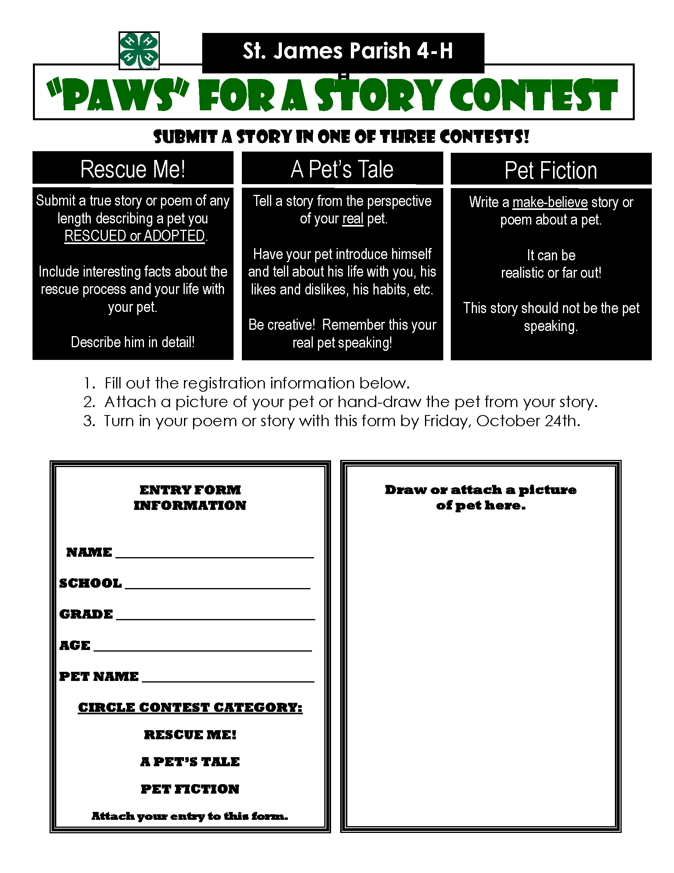


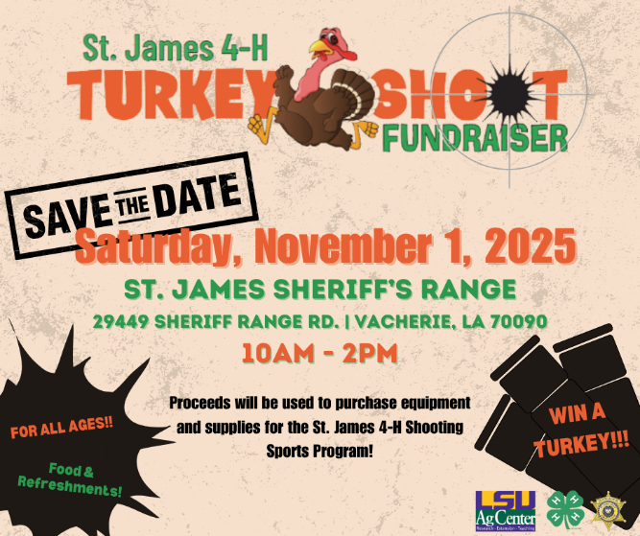
Turkey Shoot Fundraiser
Our Turkey Shoot benefitting our Shooting Sports Club will be on November 1, 2025 from 10AM-2PM. Winners from each heat will receive a gift certificate for a turkey! There will be fun for all ages and lunch for sale! More event details, competition rules and guidelines, and a list of kids and family attractions will be out soon!
Proceeds will be used to purchase equipment and supplies for the St. James 4-H Shooting Sports Program.
If you have any questions about the Turkey Shoot please reach out to Laynie Smith at larceneaux@agcenter.lsu.edu.

Beef Posters
Create a poster that markets and communicates the all-around (environmental, health, nutrition, economic, etc.) benefits of beef.
This year’s theme is Raising the Steaks Posters Due: November 21st
Contest Rules: Poster
- 22X28 Poster Board
- Participants should label the poster on the back upper right-hand corner with the following: Name, Address, Age, Grade, Parish, School
- Posters and digital designs should generate positive images and promotion of beef (not live cattle production) using the indicated theme. Posters should promote beef without projecting any negative messages towards other agricultural commodities (chicken, pork, etc.).
- The poster will be disqualified if copyrighted material is used.
Contest Rules: Digital
- Must be designed using the following: Microsoft Publisher, Adobe Photoshop, Adobe Illustrator, Canva
- Save in high resolution dpi in all the following formats: original design file, png, or pdf
- No templates may be used, all artwork must be original and from scratch
- Participants cannot use copyrighted pictures, clipart, or other materials.
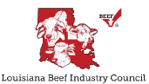
- The poster will be disqualified if copyrighted material is used
Contest Divisions
- Division I (4th-6th grades)
- Division II (7th-9th grades)
- Division III (10th-12th grades)
- Division DIGITAL – Open division. All ages compete together
Winners in each division will receive a certificate and recognition at the parish level. Each divisional winner will advance to the state level to compete for cash prizes sponsored by the Louisiana Beef Industry Council.

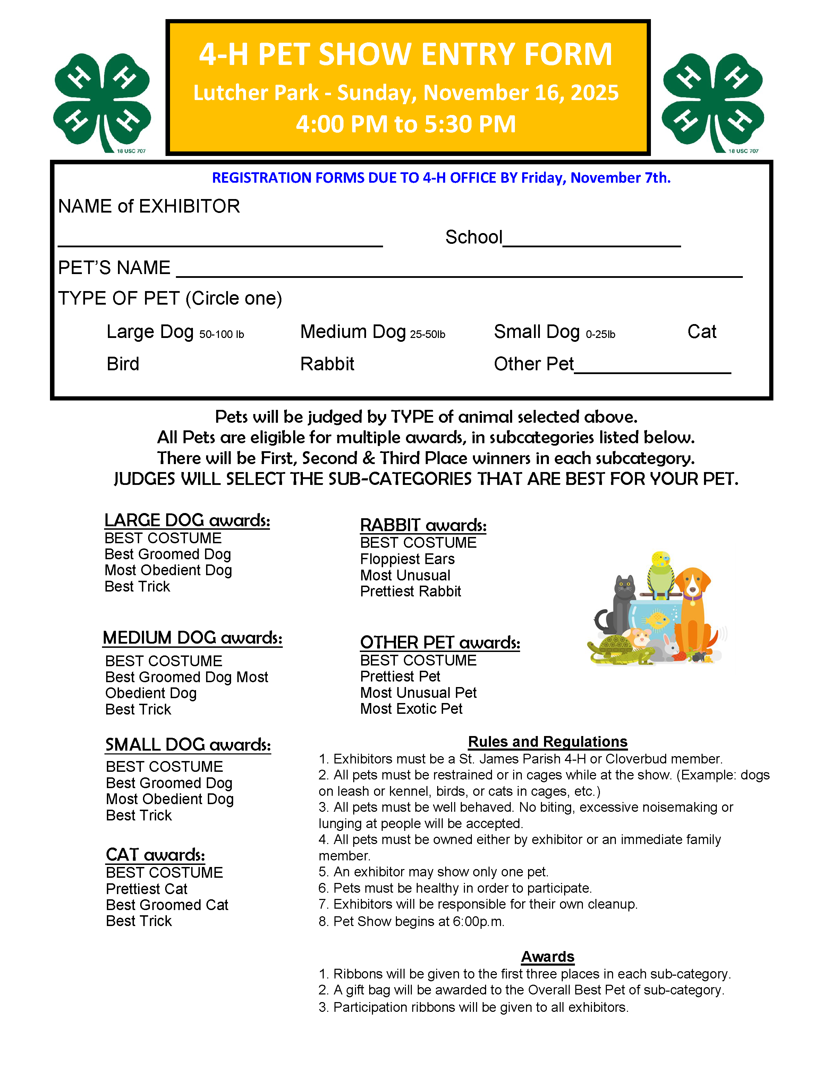Fall Cookery Contest
Monday, November 24, 2025
Dish Drop-off: 7:30am-6:00pm
All dishes will be judged on Tuesday, November 25th and winners will
be announced on our Facebook page.

Contest Rules
All rules will be strictly enforced. If you have a question, call the 4-H Office before preparing a dish.
- The contestant must be a 4-H member, all division are open to any age.
- All dishes must be prepared following all food safety guidelines from the USDA and can be found at www.FoodSafety.com.
- A contestant may enter as many dishes as they wish but can only enter one dish per division.
- Winning recipes may not be repeated in subsequent years by the same contestant.
- Contestants may only use one recipe/category.
  - Example: A contestant may not enter a jambalaya recipe in poultry and again in rice.
- The dish needs to be in a disposable plastic container, with a hard lid, with only 1 to 2 servings inside. (Dish Presentation is not a concern for the parish contest)
- There are to be NO raw eggs in the final product.
- Entries must meet all division requirements.
- One TYPED recipe must accompany the dishes.
  - Recipes will be scored according to the Recipe Evaluation below.
- All dishes, except for some Sugar Cookery entries, must be brought to the contest completely chilled in an ice chest on ice. Judges will heat up dishes if needed.
Contest Categories
Wild Game
4-H’ers must prepare a dish that contains a minimum of 1 pound of meat. The divisions are:
- Deer (ground or whole cuts) 2. Fowl (duck, quail, geese, pheasant, dove, etc.) 3. Other Game (rabbit, hog, squirrel, bison, elk, caribou, etc.)

Poultry
4-H’ers must prepare a dish which contains a minimum of two pounds bone-in meat, one-pound deboned meat, or 12 ounces of processed poultry. The divisions are:
- Chicken 2. Turkey

Sugar
4-H’ers must prepare a dish that contains a minimum of ½ cup of sugar (granulated sugar, brown (light or dark) sugar, powdered sugar, or any combination of the above).
The divisions are: 1. Cakes 2. Cookies 3. Candy/Other 4. Pies
Louisiana Commodities
4-H’ers must prepare a dish that meet division requirements. The divisions are:
- Pecan: must contain minimum 1 cup of pecans
- Rice: must contain minimum 1 cup of rice (wild rice is not cultivated in Louisiana and does not meet the requirements)
- Sweet Potato: must contain minimum 1 cup of fresh, frozen, or canned sweet potatoes

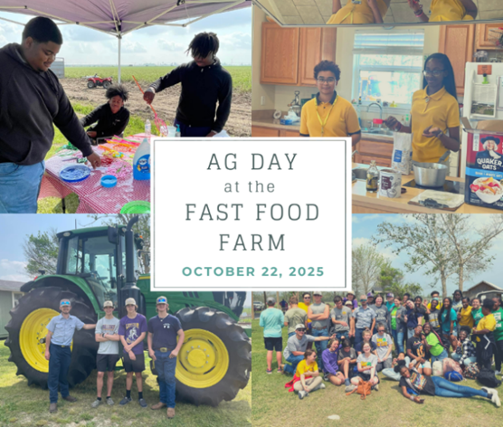


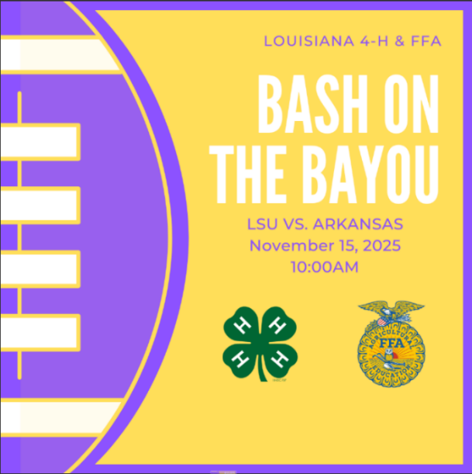

Welcome Back 4-Hers!
Carly Dufresne Laynie Smith
Associate Extension Agent Associate Extension Agent
cmboudreaux@agcenter.lsu.edu larceneaux@agcenter.lsu.edu

2204 S. Albert Street
Lutcher, LA 70071
(225) 562-2320

ADA: If you need a special accommodation for your participation in the event, please contact the office at 225-562-2320 at least two weeks prior to the event.
EEO: The LSU AgCenter is a statewide campus of the LSU System and provides equal opportunities in programs and employment.




